INTERNSHIP REPORT

Title: Gym Workout Tracker

Student Name: Siva P Anoop
Register Number: PNAYSCS028
Programme: BSc CS
College: PRAJYOTI NIKETAN COLLEGE
Internship Organization: ZIUKE Infotech
Internship Title: Full Stack Development Internship
Total Hours Completed: 60 hours
Industry Supervisor: Sruthi Sunil

ACKNOWLEDGEMENT

I would like to express my deep sense of gratitude to all those who contributed, directly and indirectly, to the successful completion of my gym workout tracker website project. This project has been an enriching learning experience that helped me develop both technical skills and a practical understanding of web-based application development.
First and foremost, I extend my sincere thanks to my guide/teacher for their invaluable guidance, constant encouragement, and thoughtful supervision throughout every stage of this project. Their timely suggestions, critical feedback, and technical insights were instrumental in shaping the planning, design, development, and final execution of this website. Without their support, this project would not have reached its present form.
I am extremely thankful to my friends and peers for their cooperation, support, and willingness to test the website and provide constructive feedback. Their suggestions helped improve the functionality, accuracy, and user interface of the workout tracker, making it more user-friendly and efficient. Their motivation and reassurance were equally important in helping me overcome challenges during development.
I would also like to acknowledge the immense support received from various online platforms, open-source communities, and technical forums. The tutorials, libraries, frameworks, and documentation available on these platforms played a crucial role in enhancing my understanding of front-end and back-end development, database integration, and responsive web design. These resources guided me in troubleshooting errors and implementing advanced features effectively.
I am deeply grateful to my family for their unconditional support, patience, and encouragement throughout the course of this project. Their belief in my abilities, emotional backing, and constant motivation helped me remain focused and determined to complete this work successfully.

Executive Summary

The Gym Workout Tracker Website is a comprehensive web-based application developed to assist individuals in systematically planning, recording, and evaluating their fitness activities. The primary objective of this project is to provide a centralized digital platform where users can maintain detailed workout logs, design personalized exercise routines, and monitor their physical progress over time. In an era where technology increasingly supports health and lifestyle management, this project integrates fitness tracking with web technology to promote consistency, motivation, and informed training practices.
The website offers a range of features designed to enhance user engagement and functionality. Users can create secure personal accounts, build customized workout schedules, and log daily exercise details including type of workout, sets, repetitions, duration, and weights lifted. The system stores this data in a structured database, enabling users to view workout history, compare past and present performance, and track progress through summaries and visual indicators. Such features support goal setting, performance evaluation, and long-term fitness planning.
From a design perspective, the website emphasizes usability, simplicity, and responsiveness. The interface is structured to be intuitive for beginners while still offering sufficient depth for regular gym-goers. Responsive design techniques ensure compatibility across desktops, tablets, and mobile devices, allowing users to access their workout records anytime and anywhere. Considerable attention was given to layout, navigation, and clarity to enhance user experience.
Technically, the project demonstrates the practical implementation of modern web development concepts, including front-end interface design, back-end processing, database integration, and user authentication. The system ensures secure handling of user data, reliable storage, and efficient retrieval of workout information. Error handling and validation mechanisms were incorporated to maintain data accuracy and system stability.
Overall, the Gym Workout Tracker Website serves as a functional and user-centric fitness management tool that bridges the gap between exercise routines and digital tracking. It simplifies workout documentation, supports analytical review of performance, and encourages a disciplined and goal-oriented approach to physical fitness. The project highlights how web-based solutions can effectively contribute to health awareness and personal fitness management.

Internship certificate

Table of Contents
1.Organization Profile
2.Internship Overview
3.Internship Experience
4.Learning Reflection
5.Appendices

Chapter 1 : Organisation Profile
The organization is focused on developing web-based fitness solutions that integrate technology with health and wellness management. Its mission is to create user-friendly platforms that help individuals plan workouts, track performance, and maintain consistent fitness routines. The Gym Workout Tracker Website reflects this goal by providing a centralized system for recording exercises, monitoring progress, and promoting a structured approach to physical fitness.

Chapter 2 : Overview
Duration:
I completed 60 hours of training.

Objectives:
- To understand the basics of web application development.
- To design a user-friendly and responsive workout tracking interface.
- To develop features for logging and managing workout data.
- To implement secure data storage and retrieval.
- To test and improve the system for usability and performance
Departments Worked In:
- Application Development Team
- Database Management Team
- Testing and Documentation Team
Tools and Platforms Used:
- HTML, CSS (for interface design)
- Basic Java / Python / PHP (as applicable)
- MySQL database
- UML diagrams (Use Case, Class Diagram)
- MS Word for documentation

Chapter 3: Internship Experience

1. Tasks Performed
During the internship, I was actively involved in the planning, design, and development of the Gym Workout Tracker Website. My tasks included requirement analysis, creating the basic system structure, designing a responsive user interface, and developing core features such as user registration, login, workout logging, and workout history management. I also worked on database design for storing user and workout information, implemented basic validation, and conducted testing and debugging to improve functionality and reliability.

2. Key Contributions
My key contributions included developing the workout logging module, organizing the database structure, and helping design a simple and user-friendly layout. I assisted in integrating front-end components with the back-end system to ensure smooth data flow. I also contributed to testing the application, identifying errors, and suggesting improvements to enhance usability and performance.

3. Challenges Faced
One of the major challenges was integrating different components of the system, particularly connecting the user interface with the database. Handling errors, ensuring data accuracy, and maintaining system stability were also challenging. Designing an interface that was both functional and easy to use required multiple revisions. Time management and debugging technical issues were additional difficulties encountered during development.

4. Personal Learning
This internship significantly improved my understanding of web development concepts, including front-end design, back-end logic, and database management. I learned how to apply theoretical knowledge to a real-world project, troubleshoot errors systematically, and work with structured project development methods. The internship also enhanced my problem-solving ability, technical confidence, and understanding of how user requirements shape software design.

5. Observations
I observed that effective planning and clear requirement analysis are crucial for successful project development. Regular testing and user feedback greatly improve system quality. I also realized the importance of teamwork, documentation, and ethical handling of user data. Overall, the experience highlighted how technology can be meaningfully applied to promote health and fitness through well-designed digital solution

Chapter 4: Learning Reflection
Academic Knowledge vs Practical Experience
While academic learning provided theoretical concepts such as databases, programming, and system analysis, the internship exposed me to real-world challenges like debugging, user requirements, and system security. Practical exposure enhanced my understanding beyond textbooks.
Role of Internal Supervisor
The internal supervisor provided continuous support by reviewing my progress, clarifying doubts, and offering valuable feedback. Their guidance helped me align academic expectations with industry standards.

Appendices
Appendix A: Internship Photo

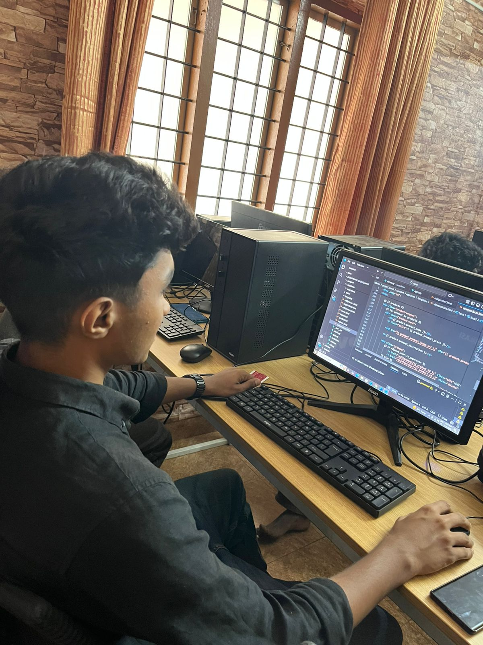Appendix B: Workbook Summary
click here

Conclusion:
The Gym Workout Tracker Website was successfully developed to help users record workouts and monitor their fitness progress in an organized way. The project applied key web development concepts and resulted in a functional, user-friendly system that supports a more structured approach to fitness management.

Signature of Student: ______________________
Date: ______________________

